SOP for Formlabs Custom trays and Wax Rims By:

Katherine Lala

Nesting: software is PreForm (blue butterfly)

* + when the dialog box opens pick the printer of choice
    - resin is Custom Tray
    - layer thickness set to fastest print 200 microns
    - apply
  + drag and drop files from the windows directory \dima Print Cast
  + 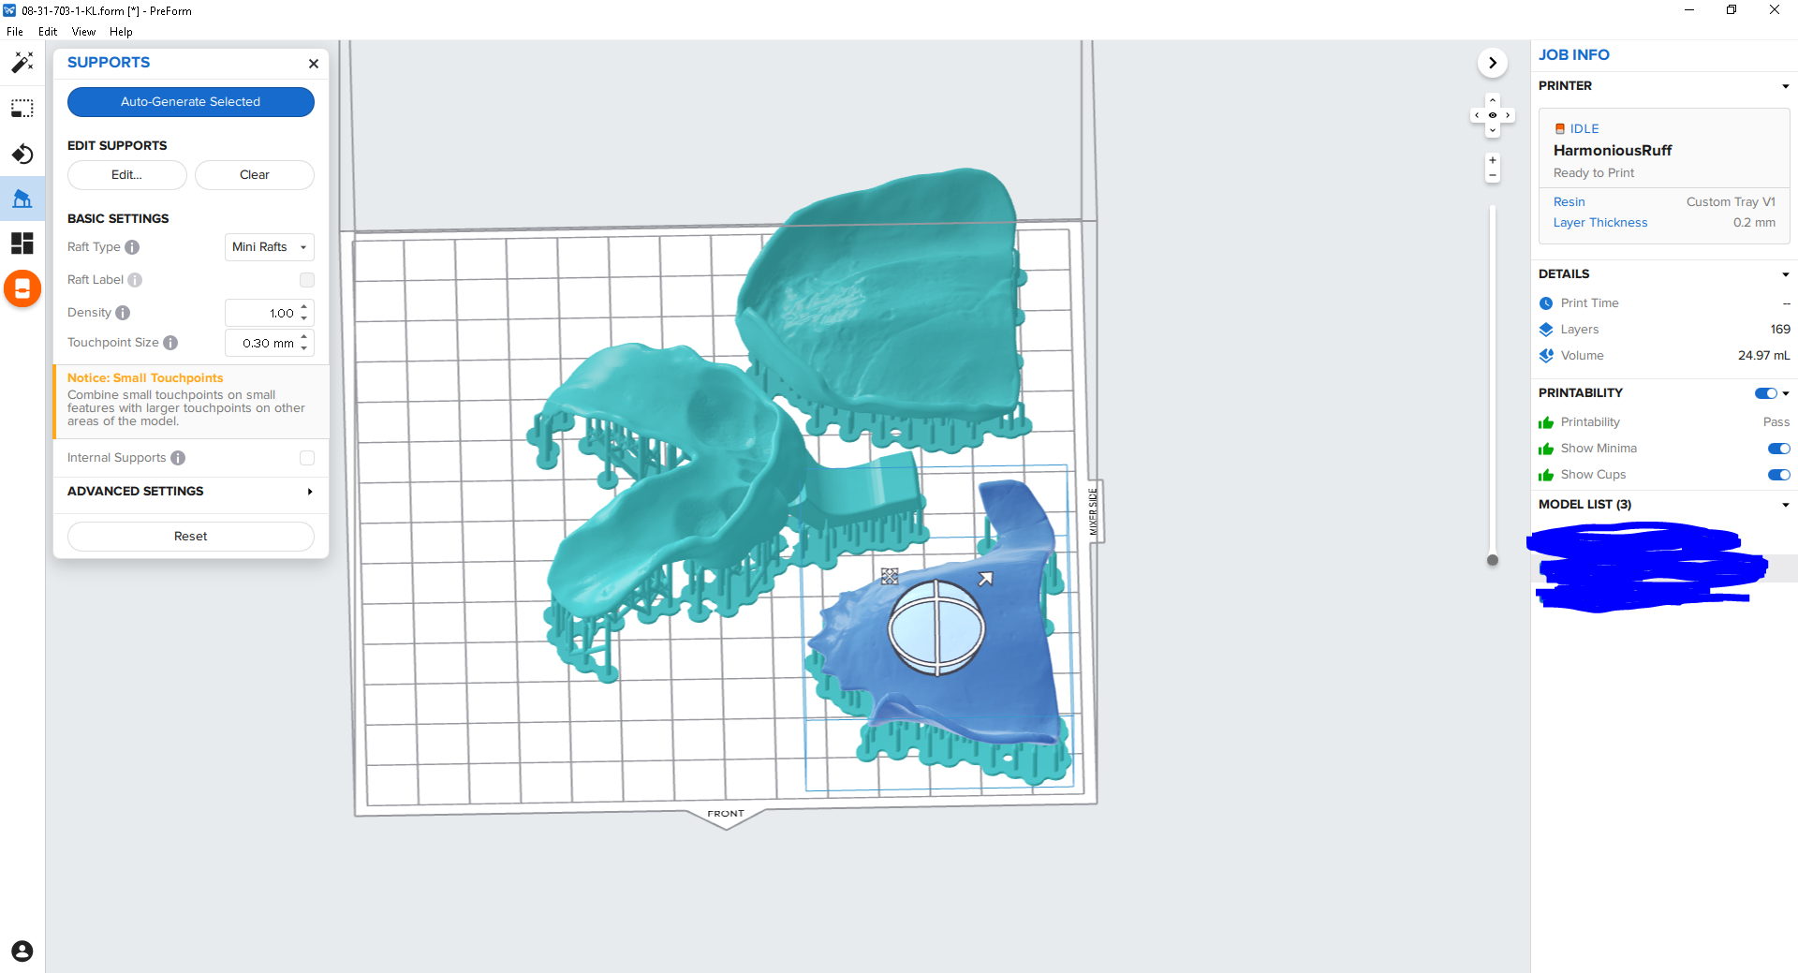Orient print with the intaglio surface away from the plate (so that minimal supports get on it.)
  + if there are a fewer than five prints lay them flat to the plate as above
  + 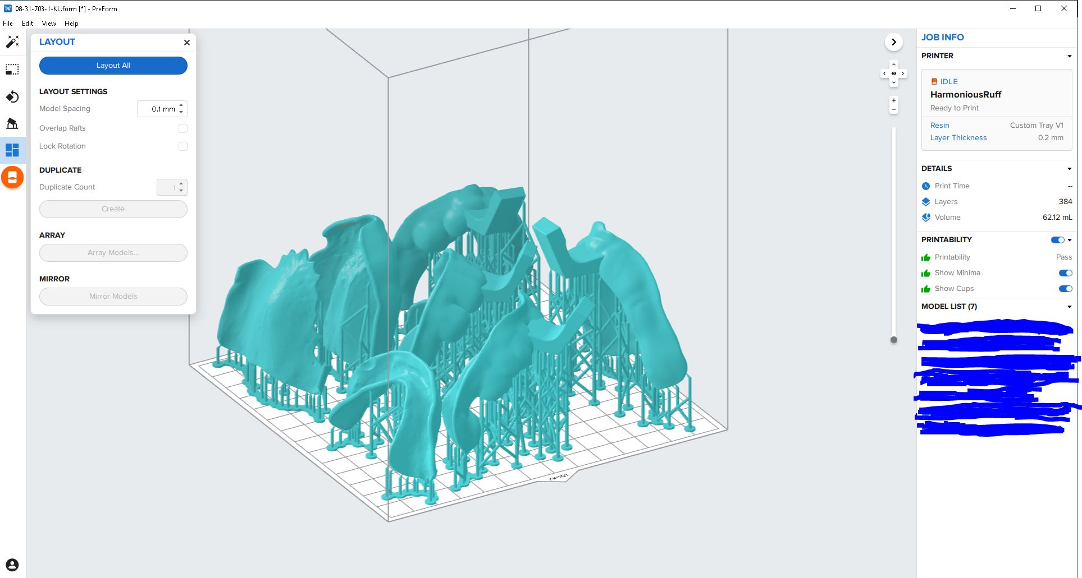if there are more than that, stand them nearly vertical to the plate distal side to plate (with a slight tilt with the intaglio side away from the plate) as above
  + Supports:
    - raft type = Mini rafts
    - no raft labels
    - density = 1.00
    - touchpoint size = 0.30mm
    - internal supports off
    - Auto-Generate All
  + Check for and supports on the intaglio surfaces. Remove if necessary.
    - For easier visibility select the model. It will turn blue and the supports will be green.
  + Layout All
  + Check the slices.
  + Save file as month-day-70(2/3)-#-initials
  + Check printability
  + use the Orange Printer button to send to the printer.

Printing:

* + Remove the resin tank and while holding upside down give it a left right shake. Put it back.
  + Open the vent on resin tank
  + check the plate (clean and proper position)
  + in the tiger mix the resin
  + verify that you have the correct file and hit print on the printer. Follow prompts.

Removal and Curing:

* + remove plate
  + at the processing station use the super bendy black handle scraper to remove the prints
  + place them in the dirty IPA for 280 seconds in the ultrasonic
  + blow out between supports and print
  + place in clean IPA for 280 seconds
  + give a light blow off and air dry for 30 minutes
  + 30 minutes in the Accu-Cure
  + remove supports and clean up with clippers

formlabs reference https://dental.formlabs.com/indications/custom-trays-guide/